Call View-

This screen will help the user to have a full view of call

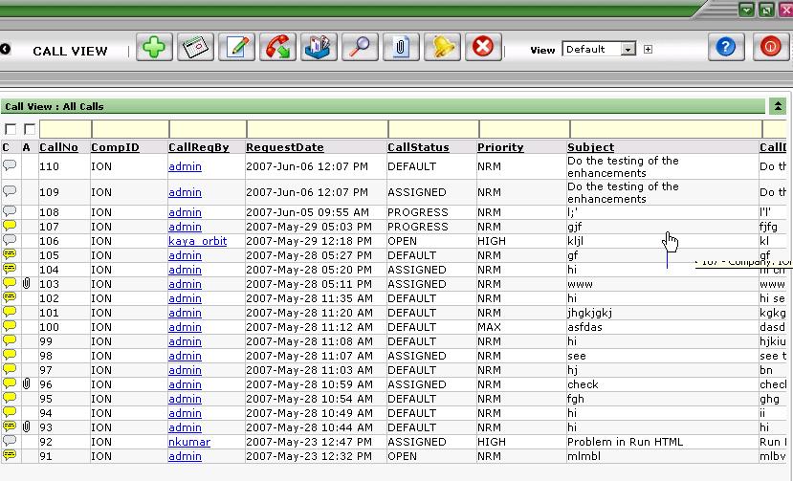

Buttons on the CALL VIEW SCREEN
ADD NEW It opens the Call Details window, we can add new call .
EDIT It will open the call edit screen and we can edit the call and its details.
Task View This button will help to view the task against the selected call
SHOW/ HIDE If we click on this button once, it will SHOW call the calls and if we click it
second time, it hides all the closed calls and only shows the calls in progress
and assigned status.
SEARCH Type any keyword in the search boxes and then click on this button, it will
only display the matching results.
ATTACHMENT With this button, we can attach files with the call or task.
Call Monitor This button is used to put any call under monitoring
CANCEL If we want to go out of this screen use the cancel button.
View My Call This button is to view your calls only

HELP Gives the brief description of the current screen.
LOGOUT Used to logout from WSS.

